**CCRS graduation requirements**

There are 5 parts to the High School and Beyond Plan required for high school graduation. They are here with instructions for how to navigate Naviance and links to video instructions:

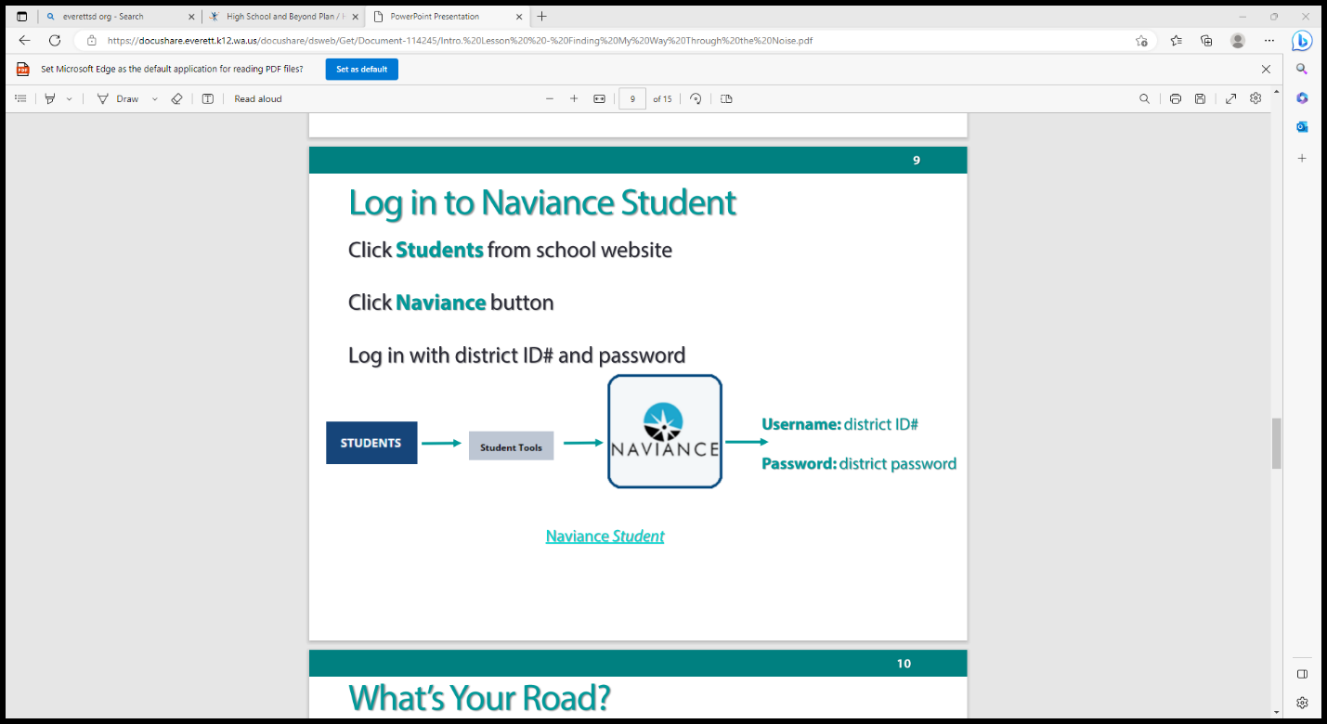

Video instructions for logging in: <https://everettsd.us-west-2.instructuremedia.com/embed/0a8f73ab-1bd3-419e-aceb-2767e46c48aa>

#1 If you haven’t already completed it, the Career Interest Profiler:

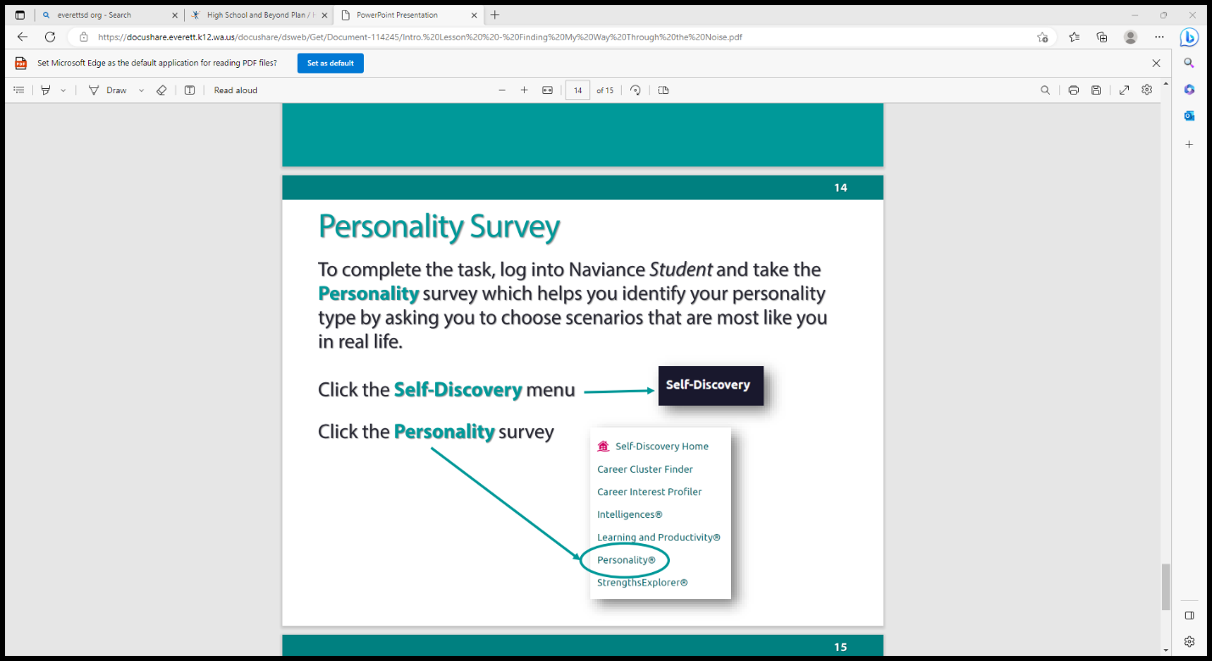

Video instructions here: <https://everettsd.us-west-2.instructuremedia.com/embed/abfdf02e-6072-458b-981b-7db476d72199>

#2 Financial Aid Survey

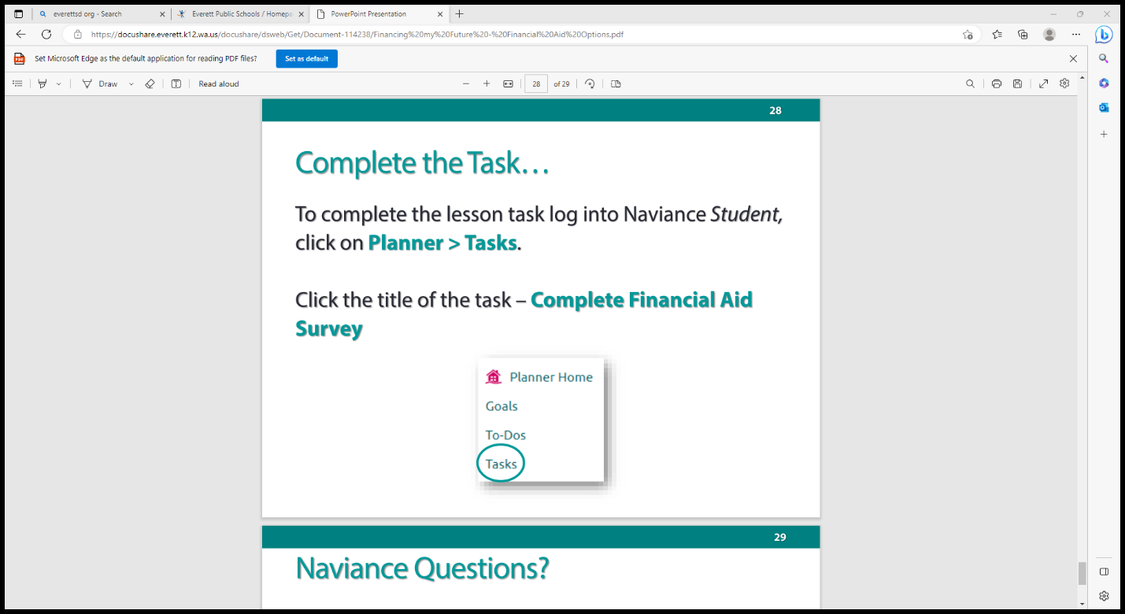

Video instructions here: <https://everettsd.us-west-2.instructuremedia.com/embed/16371fba-5070-4d2a-b763-7bdfd0a553d7>

* FAFSA: <https://www.youtube.com/watch?v=K7ihhGk8mCY>
* WAFSA: <https://www.everettsd.org/cms/lib/WA01920133/Centricity/Domain/1464/Google.mp4>

**Homeless** means lacking fixed, regular, and adequate housing. You may be homeless if you’re living in shelters, parks, motels, hotels, public spaces, camping grounds, cars, and abandoned buildings, or if you’re temporarily living with other people because you have nowhere else to go. If you’re living in any of these situations and fleeing an abusive parent, we may consider you homeless even if your parent would otherwise provide you a place to live.

**Unstable housing** includes spending time living with different family or friends for awhile.

**Unaccompanied** means you’re not living in the physical custody of your parent or guardian.

This can be certified by

* [Your high school or school district homeless liaison](https://studentaid.gov/2324/help/unaccompanied-youth-district-liaison)
* [The director of an emergency shelter or transitional housing program funded by the U.S. Department of Housing and Urban Development](https://studentaid.gov/2324/help/unaccompanied-youth-shelter-hud)
* [The director of a runaway or homeless youth basic center or transitional living program](https://studentaid.gov/2324/help/unaccompanied-youth-runaway-transitional)

#3 Resume Upload

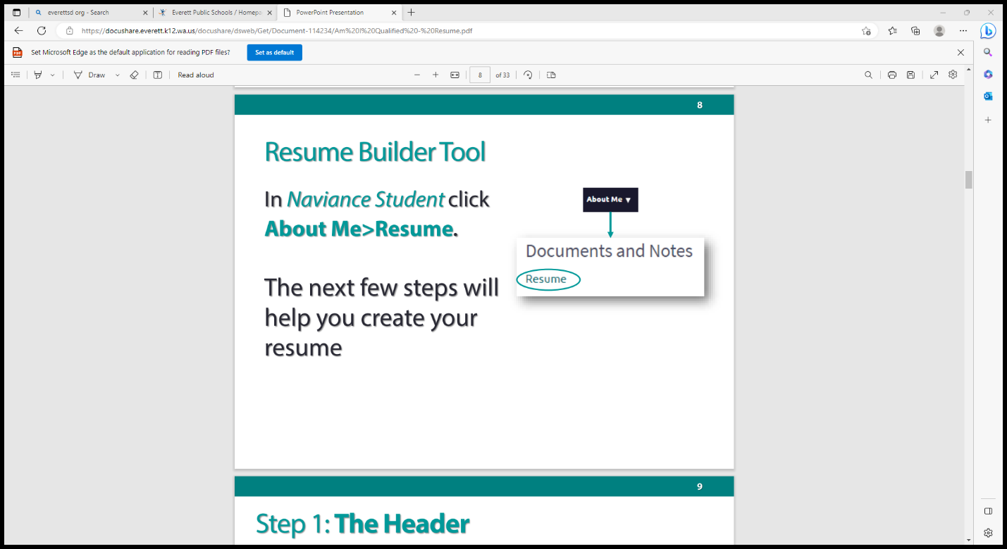

Video instructions here: <https://everettsd.us-west-2.instructuremedia.com/embed/bd577ff2-e7a7-4edb-ac0d-66b4aa7808b9>

#4 Senior Year Survey

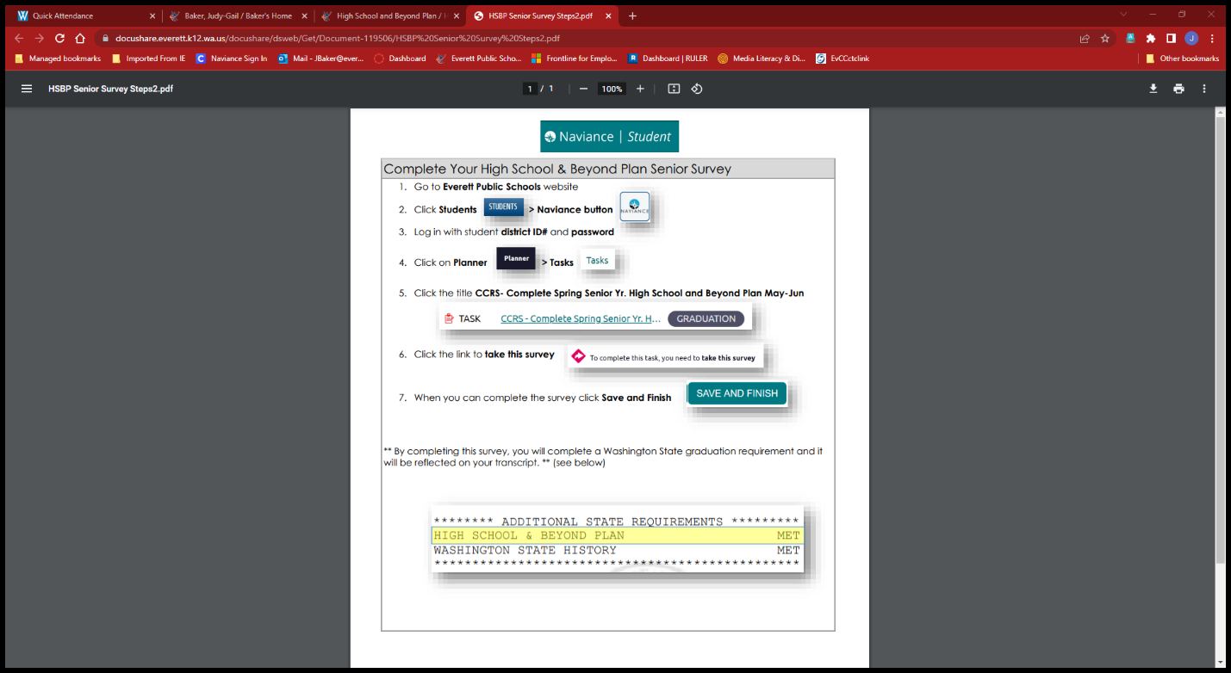

Video instructions here: <https://everettsd.us-west-2.instructuremedia.com/embed/18666d75-2ca0-4e2a-90df-e6d7a545d58d>

#5 Final High School and Beyond Plan

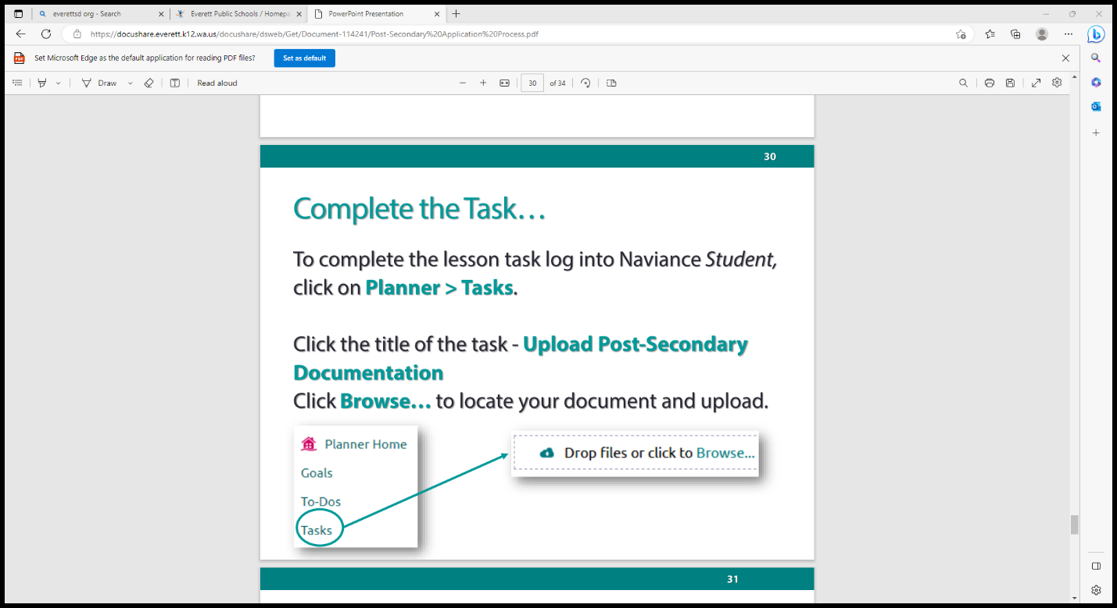

Video instructions here: <https://everettsd.us-west-2.instructuremedia.com/embed/f939e687-e8f1-4ed0-8a6a-05fb67d1ee91>

THEN

MARK YOUR COLLEGE/PROGRAM AS ATTENDING—this is the ONLY way your final transcript gets sent!!!!

Link to video for how to do it:

<https://everettsd.us-west-2.instructuremedia.com/embed/205d7b8f-1a30-43b5-b3d9-d582b7bd6094>

Steps:

1. Click on COLLEGES at the top of the dashboard screen.

1. Choose Colleges I Am Applying To..

1. Scroll to the bottom of the list of your colleges and fill in the College I am Attending Box.

1. Click UPDATE.